Bakersfield College
Program Review – Annual Update 2015

I. Program Information:
Program Name: EOP&S/CARE/CalWORKs

Program Type: Instructional Student Affairs Administrative Service

Bakersfield College Mission: Bakersfield College provides opportunities for students from diverse economic, cultural, and educational backgrounds to attain Associate and Baccalaureate degrees and certificates, workplace skills, and preparation for transfer. Our rigorous and supportive learning environment fosters students’ abilities to think critically, communicate effectively, and demonstrate competencies and skills in order to engage productively in their communities and the world.

Describe how the program supports the Bakersfield College Mission:

The EOP&S, CARE and CalWORKs Programs at Bakersfield College support student success by providing a better understanding to open access and an awareness of resources, foster independence and being advocates for transformation. In general, the EOP&S, CARE and CalWORKs programs at Bakersfield College educates and embraces eligible students from diverse backgrounds through a foundation of mutual respect and understanding.

The program staff commit to the following actions:

- To eliminate barriers and ensure access to post-secondary education for all eligible students.
- To provide personal accessible services
- To facilitate the transfer and career placement of students
- To facilitate the successful completion of student educational goals and objectives
- To facilitate educational pathways
- To positively affect student self- concept, self-esteem and self-advocacy.

Program Mission Statement:

Extended Opportunity Programs and Services (EOP&S)

The EOP&S Program encourages student success through enrollment and retention of students affected by language, social, and economic hardships by providing over and above services, which empowers students to achieve their educational objectives and goals.

Cooperative Agencies Resources for Education (CARE)

The CARE Program collaborates with the Kern County Department of Human Services providing opportunities for EOP&S students who are single head of household in an effort to strengthen students’ retention, graduation, and transfer rates to become economically self-sufficient.

California Work Opportunity responsibility to Kids (CalWORKs)

The CalWORKs Program collaborates with the Kern County Department of Human Services to provide supportive services and resources to students in transition to achieve long term self-sufficiency and transform lives.

II. Progress on Program Goals:
- List the program’s current goals. For each goal (minimum of 2 goals), discuss progress and changes. If the program is addressing more than two (2) goals, please duplicate this section.

Program Goal | Which institutional goals from the Bakersfield College Strategic Plan will be advanced upon completion of this goal? (select all that apply) | Progress on goal achievement  (choose one) | Comments
1.  Increase persistence from Fall to Spring within all programs, establishing a baseline persistence rate for review the following year. | 1: Student Learning  2: Student Progression and Completion  3: Facilities  4: Oversight and Accountability  5: Leadership and Engagement | Completed: __________ (Date)  Revised: __________ (Date)  Ongoing: _9/20/15__ (Date) | The program provides intrusive case management programmatic services to ensure early, mid and late semester checks are reviewed to ensure students are meeting their goals, following comprehensive student educational plans and are on track.  The 2014-2015 academic year was the baseline year for tracking persistence from Fall to Spring. Exit Interviews are provided for all students and is required towards the end of each semester. The baseline retention was 73.2%. This goal will remain ongoing to address enhancements through the exit interview/contact process with students.  It will be a continuous goal for at least three years to increase by 3 to 5% the following year.
2.  For all programs, 80% of probation students will make all 3 counseling contacts and have success contracts on file. | 1: Student Learning  2: Student Progression and Completion  3: Facilities  4: Oversight and Accountability  5: Leadership and Engagement | Completed: __________ (Date)  Revised: __________ (Date)  Ongoing: _9/20/15___ (Date) | The goal was established to ensure Probation students succeed and to review our processes with probation students. The programs require all students to complete a one-on-one probation workshop with a counselor, with 3 follow-up appointments with the same counselor. With that, the program goal was set to have at least 80% of probation students will complete all 3 counseling contacts and have a success contract on file. The constant contact and follow-up with the students should increase student success for all probation.  During Fall 2014, 56.4% probation students in the EOP&S program completed 3 counseling contacts while in the Spring 2015 semester contact completion increased by 14.4%. The program goal has not yet been met, but progress is demonstrated with the increase of probation students completing contacts from Fall to Spring Semester. This goal will be ongoing until the goal is met.

- List new or revised goals (if applicable)

New/Replacement Program Goal | Which institutional goals will be advanced upon completion of this goal? (select all that apply) | Anticipated Results
Increase the number of EOP&S students who are registered for courses during the priority registration period by 60%. | 1: Student Learning  2: Student Progression and Completion  3: Facilities  4: Oversight and Accountability  5: Leadership and Engagement | Through workshops, targeted messages and through the counselor the goal is to increase the number of students who utilize priority registration to register for courses.
Summer Bridge  Students will have a greater knowledge of key dates and Academic Policies by the end of the Workshop series. This will be demonstrated by 80% of the students in the EOPS Bridge Workshop earning a 75% on the Post Test. This test will be administered at the start of the first day of the Workshop and at the end of the last day of the workshop. | 1: Student Learning  2: Student Progression and Completion  3: Facilities  4: Oversight and Accountability  5: Leadership and Engagement | The Summer Bridge workshop series is designed to assist EOP&S/CARE students with becoming more knowledgeable about program requirements and Academic Policies; including, degree/transfer requirements, in an effort to increase student success and retention. The main focus for this pilot series will be on Academic Policies.  EOP&S/CARE are programs designed to provide additional services to underrepresented students in an effort to bridge the achievement gap. Though Counselors meeting with students in the program a minimum of three times, first semester students are sometimes unclear about why they are taking certain courses and which areas these courses will fulfill in regards to certificate, degree and, transfer requirements. These workshops functioned as a vehicle to provide vital preliminary information before the student meets with their EOP&S/CARE Counselor to maximize their appointment times.
Increase the number of foster youth participating in the EOP&S program. | 1: Student Learning  2: Student Progression and Completion  3: Facilities  4: Oversight and Accountability  5: Leadership and Engagement | The 2015-2016 academic year will be a baseline year. EOP&S will be involved with the Foster Youth Work group and with Financial Aid in working with the Foster Youth population

III. Trend Data Analysis:
Highlight any significant changes in the following metrics and discuss what such changes mean to your program.

- Changes in student demographics (gender, age and ethnicity).

The predominant gender of EOPS students remains Female; however, there was a 3% increase in our male population for the 14-15 school year. It appears that the male population of EOPS students may be slowly on the rise.
The EOP&S student population still consists primarily of students between the ages of 20-29; coming in at 45% of the program’s population in the 14-15 academic year. Totaling an average of 44.8% over the years of 2010-2015. A 13% increase must be noted for students falling between the ages of 19 and younger between the years 2012-2015. It appears that the EOPS student population of 40 and over has seen a 7 % decrease in students from 2012-2015.
The Hispanic student population for EOP&S students has seen a 16% increase from 2010-2015; unfortunately, the African America population has seen a 10% decrease from 2011-2015. However, both ethnic populations are still higher within the EOPS student population than they are institutionally.
The CARE population, like EOP&S, primarily consists of females. In fact, 96% of the CARE population is female. The predominant age group among CARE students is between the ages of 20 and 29. The predominant ethnicity of this population is Hispanic / Latino. Sixty seven percent of all CARE students in 2014-2015 were Hispanic/Latino. This ethnicity has seen a 21% increase from 2010-2015. The African American Population for CARE students has decreased from 2010-2015. Yet, still remains higher at 16% than the percentage of African American’s campus wide for the 2014-2015 academic school year.
Despite the 6% decrease in female participants from 2013-2015, the CalWORKs student population consists primarily of female students. It must be noted that from 2013-2015 the CalWORKs’ male population has seen a 6% increase in CalWORKs participation. The predominant age group for CalWORKs students is between 20-29 years old; even with the group’s 6% decrease from the 2013-2014 academic year. An 8% increase can be noted for student ages 30-39 from 2013-2015.
The CalWORKs Student population primarily consists of Hispanic/Latino students. The Hispanic/Latino population has decreased by 6% from 2012-2015, but still remains higher than the overall Hispanic/Latino population at Bakersfield College. Conversely, the African American CalWORKs student population has increased by 5% from 2013-2015.
- Changes in enrollment (headcount, sections, course enrollment and productivity).

The headcount for EOP&S students seems to follow a predictive trend of a year of decrease followed by year of increase. The 14-15 year was a year of decrease, therefore a year of increase should follow. This will be especially true because we have increased the number of EOP&S students to be accepted into the program for the 15-16 school year. An increase in the program’s overall headcount will follow.
EOPS student Enrollment at census has steadily been increasing from 2012-2015. A 28% increase in EOPS students enrolled at census can be noted between these years. Average Enrollment per student has increase by 1.3 percent from the 2013-2014 academic year to the 2014-2015 academic year.
The headcount for CARE students has decreased by 48% from 2010-2015. We are currently ramping up efforts to increase the number of CARE participants. CARE students enrolled at census has decreased by about 53% from 2010-2015. The average enrollment per student is higher at 6.3 % for the 2014-2015 academic year, than the average enrollment of Bakersfield College’s overall student population.
The student head count for CalWORKs students has steadily declined from 2010-2015, as has the enrollment of CalWORKs students at census. The smallest decrease in three years for enrollment at census was between the 2013-2014 and 2014-2015 academic year (.002%). The average enrollment per student has increased from 2012 – 2015 by .2%
- Success and retention for face-to-face, as well as online/distance courses.

EOP&S has phenomenal Retention and Success rates as are evidence by the Institutional Research and Reporting data. The program has seen a 6% increase in Retention from 2010-2015, steadily increasing each year. This holds true for the program’s Success rates, as they have also increased by 10% within the same time frame. EOP&S Retention and Success rates for the 2014-2015 academic year are higher than the success rates for All Students in that same year.
Both CARE Success and Retention rates have shown an increase from 2010-2015 and are on par with the Institution’s overall Success and retention rates. Success rates have improved by 4% this past year alone.
The Retention rate for CalWORKs students has continued to increase by about 3% each academic year starting in 2011, and remains higher at 87% than the overall student retention rate for the campus. The success rate for CalWORKs students follows a similar trend and has also steadily increased by 14% from 2011-2015.
- Changes in the achievement gap and disproportionate impact (Equity).

EOP&S students awarded an AA and/or AS has increased by 9% from 2013-2015 and 24% from 2012-2015. Though we are below the average for all students completing an AA/AS, data suggests that this will not be the case for long. EOP&S students completing a certificate has steadily declined from 2011-2015 by 16%; however, EOP&S students are completing certificates 6% more than the entire student population as a whole. The total for AA/AS degrees and certificates awarded continues to increase among EOP& S students.
The percentage of AA/AS degree awarded to CARE participants has increased by 23% from 2012-2013 to 2014-2015. The awarding of Certificates for this same population has decreased from 2012-2013 to 2014-2015 by 23%. The percentage of awards by type for CARE students is 11% more than the overall student population. There is a steady increase in the Total awards granted from 2010-2011 to 2014-2015.
The percentage of certificates awarded has increased by 5% from 2013-2015, and still remains higher that the overall student average for certificates awarded. During that same time frame the awarding of AS/AA degrees has decreased by 5%. The total awards for both AA/AS degrees and certificates rose by 14% from 2011-2013, but decreased by 8% between the 2013-2014 and 2014-2015 academic school year.
- Other program-specific data that reflects significant changes (please specify or attach). All Student Affairs and Administrative Services should respond.

IV. Program Assessment (focus on most recent year):
- How did your outcomes assessment results inform your program planning? Use bullet points to organize your response.
It is the practice to discuss the programs’ assessment results annually during the year end staff planning retreat. This process allows a holistic approach to input and discussion from the team in reviewing the previous goals and assessment results and planning for the next year’s goals, focus and needs. The department highlighted some of the achievements from 2014-2015:

The department highlighted some of the achievements from 2014-2015:

- More students completing at least one contact
- Reduced MIS errors with state reporting
- Reduced the number of files without student and staff signatures (this is required by the grant and is reviewed during audits)
- Reduced student paperwork by streamlining student files
- Created a facebook and remind me app to increase communication modalities to students
- Developed and planned the first University field trip for EOP&S students
- Increased the number of care contacts

- How did your outcomes assessment results inform your resource requests? The results should support and justify resource requests.

- This process has led to the conclusion there is a critical need for additional counseling staff and support staff to meet the student mandates as outlined in the categorical regulation. Increasing the three contacts mandate per students served leads to an additional full time counselor. The goal is to expand the EOP&S services to include academic support structures and the amount of students participating in the program by 1,000 students. Creating pathways and increasing case management loads needs adequate staffing. The goal is to also meet the strategic directions and Achieving the Dream Data. The focus will be on the following:

- Additional tutoring hours
- Supervised Study Areas
- Summer Bridges
- EOP&S Student Development Class
- Study Skills Workshops
- Technology assistance to students
- Summer EOP&S Jump Start Classes

- Element 1 (ESL and Basic Skills Completion, Student Success Indicator C): Focus on successful completion of initial college-level or gateway courses in English and Math within the EOP&S student cohorts as tracked in the ATD successful completion in gateway English/Math who completed gateway courses. EOP&S students who are not college ready and are enrolled in English are 16% less successful than the general population and are 7% more successful in completion in the Math gateway courses compared to the student population. This data includes student cohorts already participating in the EOP&S program
Hispanic students who do not participate in the program over a five year span since 2008 demonstrated low success in remedial English according to the disproportionate impact data outlined in the Student Equity Plan
Goal: Increase successful completion of English and Math Gateway courses by 5% each year compared to the general student population.

- Element 2 (Degree and Certificate Completion and Transfer, Student Success Indicators D and E): Focus on successful graduation and transfer rates among Hispanic students. Hispanic students are disproportionally impacted related to transfer. EOP&S cohorts within the ATD data are 4% more successful than the general student population attaining a degree and transferring within 3 years. Hispanic students are meeting the 30 unit milestone but dramatically decrease in percentage of completion beyond the 30 unit milestone.
Hispanic students reach a high level of transfer prepared, but are disproportionally impacted when it comes to transferring.
Goal: Increase successful completion of degrees and transfer rates by 5% compared to the general student population.

- Element 3: (Course Completion, Student Success Indicator B) Focus on successful course completion. Compared to successful course completion within the ATD cohorts, EOP&S student are completing 4% less than the general student population.
Goal: Increase successful course completion by 4% compared to the general student population.

The assessment results also indicated the number of contacts per the one full time counselor does not meet the regulations of the categorical. Last Fall 2014, the EOP&S/CARE/CalWORKs counselor conducted approximately 580 EOP&S individual counseling contacts. During Spring 2015, the counselor conducted 617 EOP&S individual counseling contacts and 381 group counseling contacts. Four Adjuncts were hired for EOP&S students to meet the mandated three contacts. For Fall 2014, the EOP&S Adjunct Counselors conducted 976 individual counseling contacts and 23 group contacts. During Spring 2015, there were only three adjunct counselors which conducted 1,198 individual counseling contacts and 64 group contacts. In total, 3,371 individual contacts were made with students in the EOP&S program with EOP&S adjunct counselors, and the EOP&S/CARE/CalWORKs Counselor and 468 group contacts. One Adjunct Counselors were hired for the CalWORKs program to provide counseling, otherwise there would not be a counselor to meet the needs of CalWORKs students (orientations, intake, needs assessment, developing a SEP, workshops).

- How do course level student learning outcomes align with program learning outcomes? Instructional programs can combine questions C and D for one response (SLO/PLO/ILO).

The counselor in the program at this time does not teach student development courses. We are in the process of developing an EOP&S Renegade 101 course for next year.

- How do the program learning outcomes or Administrative Unit Outcomes align with Institutional Learning Outcomes? All Student Affairs and Administrative Services should respond.

The programs strongly align with the institution’s learning outcomes by establishing strong connections with the student populations served. These intrusive connections are made by the following:

- Individual appointments (3 Contacts EOP&S, 2 CARE, 2 CalWORKs)
- Extended learning in the life skills workshops
- Development of Comprehensive Student Educational Planning
- One to one assistant with Students who are on Academic Probation
- Intrusive Follow-up
- Provide students with the tools necessary to graduate and/or transfer
- Case Management
- Needs Assessment Individualized Intakes
- Tracking and monitoring
- Peer Mentoring
- Progress Reports
- Interventions

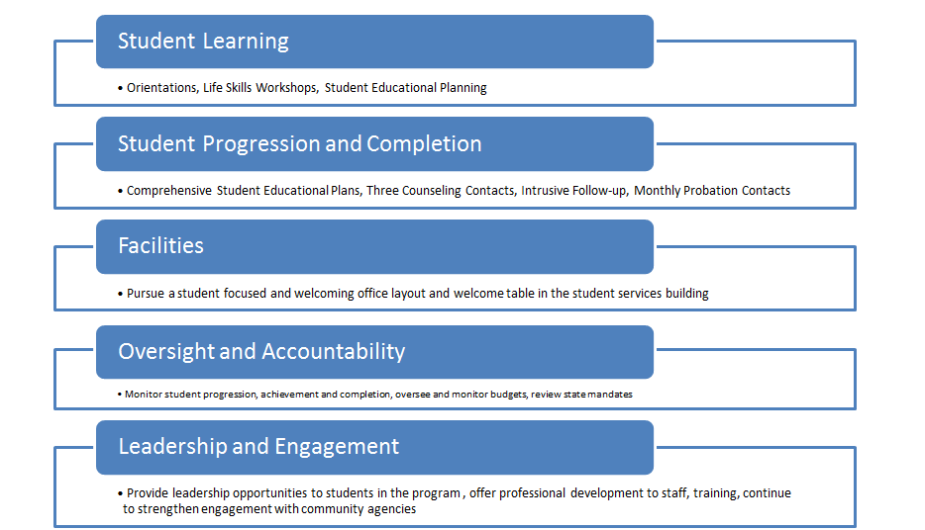

Institutional Learning Outcomes:
Think: Think critically and evaluate sources and information for validity and usefulness.
Communicate: Communicate effectively in both written and oral forms.
Demonstrate: Demonstrate competency in a field of knowledge or with job-related skills.
Engage: Engage productively in all levels of society – interpersonal, community, the state and the nation, and the world.

- Describe any significant changes in your program’s strengths since last year.

- Streamlining Counseling Contacts among all three programs (EOP&S, CARE and CalWORKs): If an effort to streamline contacts amongst all three programs a full time counselor split between all three programs was hired. A student who is EOP&S, CARE and CalWORKs can meet with the counselor for a comprehensive student educational plan, needs assessment, review the welfare to work plan from the county and provide a county referral and have the contact meet the regulatory guidelines for all three programs, thus reducing the number of contacts the student has to complete for each program. The program file folders were also merged into one file instead of having three separate files reducing space and having one central location in the files for a the EOP&S, CARE and CalWORKs Counselor to view for all program information on the student.
- Above and Beyond and In Addition to Services: In the course of students participating in the program, students have the opportunity to receive services and support that are “over and above” those provided by the college for the student population at large. For this reason, the program curriculum is based on reaching underrepresented students and improving their chances for success through innovative and holistic approaches. The EOP&S program curriculum is designed to address four service areas: Academic, Financial, Personal and Social Support Services.
EOP&S Student

- University Visits
- Culture Activities and Awareness
- Social Media
- Replacement Position for Educational Advisor
- Hired one EOP&S,CARE and CalWORKs Counselor
- Summer Bridge Course
- Remind Me App
- Streamline the CARE/CalWORKs Certification form with the County
- Reduced the number of EOPYS students on academic probation
- CARE Brown Bag Series

An Area of strength included reducing the number of students on Academic Probation who were participating in the program. EOP&S Students who are on academic program have to meet with a counselor on a monthly basis and submit a progress report monthly as well. There were 17.18% EOP&S students whose GPA fell within 0.00 to .99% and within one semester this percentage decreased by 15.88%. This is an example of intrusive contact and follow-up services.

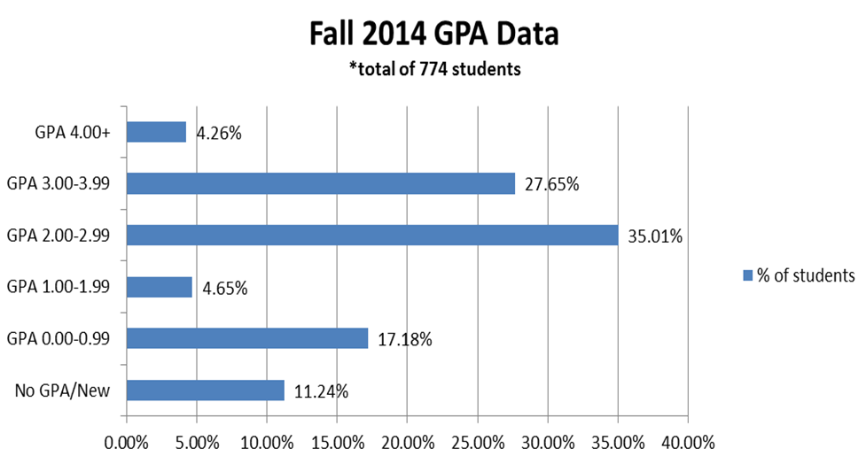

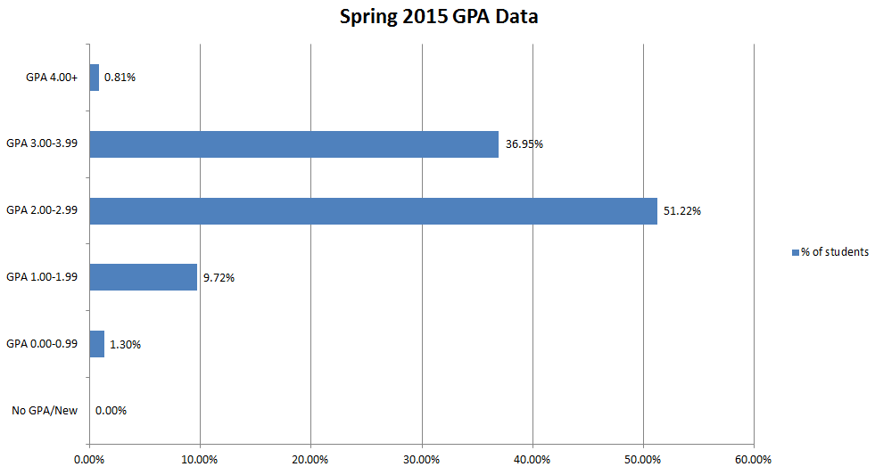

- Describe any significant changes in your program’s weaknesses since last year.

There are four program weaknesses since last year that affect the program overall:
- Lack of adequate staffing to provide the essentials of the program to students
- There is only one full time counselor (60% EOP&S) to meet with 900 students per semester with equals $2,700 contacts per semester (there are not sufficient appointment slots to meet with requirement currently)
- The current location does not provide confidentiality and security of files
- The CalWORKs Program needs at least a part-time manager to assist with the programmatic components of the CalWORKs Program.
There is not sufficient staffing for all three programs to adequately address the mandated aspects of what is required for every student contact and goal. There are not sufficient counseling appointments slots for students at the Bakersfield College main campus and at the Delano campus causing students to wait long periods of time to schedule their three counseling contacts or for students to complete the mandated three counseling contacts before the end of each semester. The staffing levels have still not been restored since the 2009-2010 categorical reductions. As of this year, the EOP&S program has been fully restored to 2008-2009 funding. This provides opportunity to expand services and grow. The program cannot grow unless there is additional staffing. The rebuilding of adequate staffing can begin to be rebuilt to address the mandated aspects of the programs:
- Orientations
- Long Term Educational Planning
- Three Student Contacts
- Mutual Responsibility Contracts
- Advisory Committee
- Outreach
- Recruitment
- Registration Assistance for Priority Enrollment
- Counseling
- Advisement
- Career Planning/Employment Services
- Transfer Assistance
- Intrusive Follow-Up
- In-Term Contacts Sessions
- Exit Interviews
- Work Referrals
- Needs Assessments
- Liaisons between the programs to the Kern County Department of Human Services
- MIS Data
The part-time CalWORKs manager is a replacement position request due to meeting compliance with the State Chancellor’s Office. The EOP&S/CARE Assistant Director used to be 90% EOP&S/CARE and 10% CalWORKs on a waiver approved by the EOP&S State Chancellor’s Office. The waiver has sunset and now the regulation states if there is a part time Director for EOP&S (the Director overseeing the EOP&S/CARE programs have additional responsibilities) then there has to be a full-time 100% Assistant Director dedicated to the EOP&S/CARE programs. The work within this program at a manager’s lever includes the following:
- Coordination of CalWORKs activities
- Recruitment of CalWORKs students
- Liaison to the Kern County Department of Human Services
- Aligning the student’s major to work on campus
- Assist students with self-sufficient
- CalWORKs work-study budget
- Aligning Academic Support Services
- Tracking and monitoring the CalWORKs Cohort
- Increase the CalWORKs participants
- Provide intrusive follow-up
- Student Supplies Budget
- Track Certifications from the County Office
- Student File Alignment and eligibility documentation review
- Create Job Search and Skills Workshops in alignment with the County Office
This position is critical since it interfaces with the county office to align with the county goals, college and program goals. The county is requiring additional requirements for its Bakersfield College participants and it takes at least a part-time manager to review compliance, sustain the relationship with the county office and to scale the CalWORKs program.
The EOP&S, CARE and CalWORKs Programs are in the process of reorganization.

The recruitment requirement within the EOP&S/CARE/CalWORKs programs affects the overall number of students who are approved to participate in the program. Effective recruitment relies on adequate staffing levels to meet the needs of the program mandates. The CARE and CalWORKS programs have been declining in students participating in the program due to a lack of staff to recruit on and off campus. There is not a full-time EOP&S/CARE/CalWORKs staff member at the Delano campus. The staff alternate days covering Delano to provide services. EOP&S/CARE/CalWORKs students do not have access to an EOP&S/CARE/CalWORKs staff member throughout the week. The Delano EOP&S/CARE/CalWORKs students have been declining due to staffing and coverage in Delano.
Currently, the location of the programs does not provide effective confidentiality and security of program files and supplies. The programs are located in an open area with a couple of cubicles. There are two cubicles utilized by EOP&S, CARE and CalWORKs adjunct counselors. These spaces are not confidential since the ceiling is open. There are walls and a door. There have been a couple of concerns with confidentiality when the adjunct counselors counsel students with personal matters. There have been a couple of incidents with students crying or sharing a personal matter and their voices can be heard in the study area.

- If applicable, describe any unplanned events that affected your program.

Staffing changes caused delays with meeting the 3 counseling mandates with the retirement of one full time EOP&S counselor as well as staffing changes. The goal and requirement is to meet all of the EOP&S/CARE/CalWORKs mandates. There were funds that had to be returned due to staffing changes and staff being out of the office without having replacements.

V. Assess Your Program’s Resource Needs: To request resources (staff, faculty, technology, equipment, budget, and facilities), please fill out the appropriate form. https://committees.kccd.edu/bc/committee/programreview

- Human Resources and Professional Development:
- If you are requesting any additional positions, explain briefly how the additional positions will contribute to increased student success. Include upcoming retirements or open positions that need to be filled.

Please see the attached position requests.

- Professional Development:
- Describe briefly the effectiveness of the professional development your program has been engaged in (either providing or attending) during the last year, focusing on how it contributed to student success.

The EOP&S, CARE and CalWORKs staff participates in ongoing professional development trainings and activities. The staff have attended and are involved in some capacity in the following:

- Counseling Department Meetings
- Probation Task Force
- Student Educational Planning Work Group
- ISIT Committee
- Foster Youth Advisory
- EOP&S Association Conference
- EOP&S/CARE Spring Training
- CalWORKs/CARE Training Institute
- County Conference
- County Trainings
- Student Success Stewards
- MIS Work Group
- Degree Works Trainings
- MIS Trainings
- State Region Meetings
- Curriculum Committee
- Career Center Committee
- Dress for Success
- Latina Leaders

The staff contribute, attend and are involved in key state and campus initiatives in addressing student success through EOP&S, CARE and CalWORKs. The collaborative professional development opportunities have resulted in continuous participation, innovation and improvements.

- What professional development opportunities and contributions can your program make to the college in the future?

The staff in the programs each stem from areas of expertise. The staff can provide professional development workshops in educating the campus community in the programs student success model, a model which has been successful since 1969. Co-presenting with community partners is also an option.

- Facilities:
- How have facilities’ maintenance, repair or updating affected your program in the past year as it relates to student success?

n/a

- How will your Facilities Request for next year contribute to student success?

The facilities request will address security and confidentiality as well as safety. Addressing student success includes the safety of staff members and security of files/supplies in the area. The waiting area is in the process of being turned into a supervised study area for EOP&S/CARE/CalWORKs students.

C. Technology and Equipment:
- Understanding that some programs teach in multiple classrooms, how has new, repurposed or existing technology or equipment affected your program in the past year as it relates to student success?

New desktop computers with dual screens were purchased with EOP&S and CalWORKs funds for all staff as well as a color printer unit to be used by all staff members in the unit.

- How will your new or repurposed classroom, office technology and/or equipment request contribute to student success?
- Discuss the effectiveness of technology used in your area to meet college strategic goals.

The EOP&S/CARE/CalWORKs programs utilize the District’s MIS system (Banner) for all reporting purposes to the State Chancellor’s Office. The EOP&S/CARE programs maximize the use of its internal data system- Microsoft Access. This software maintains all student information up to date, provides the opportunity to keep track of student academic progress, provide live reports regarding our student population, contacts, units, etc., and provides organization of book and grant totals per students.

The EOP&S/CARE programs staff would like to recommend the following:
- Implement the use of SARS Text
- Create an EOP&S/CARE/CalWORKs app
- Incorporate clickers in the orientation
- Incorporate videos during the orientations

D. Budget: Explain how your budget justifications will contribute to increased student success for your program.

VI. Conclusions and Findings:
Present any conclusions and findings about the program. This is an opportunity to provide a brief abstract/synopsis of your program’s current circumstances and needs.

Overall, The EOP&S/CARE/CalWORKs programs are moving forward with streamlining, accountability, student success, continuing to address equity, access, data tracking, analyzing data and intrusive follow-up services while remaining in compliance. Analyzing the data will help increase EOP&S/CARE/CalWORKs efforts aligning with advocacy for the students the program serve. The fact that EOP&S/CARE/CalWORKs receives state categorical funding on an annual basis allows the programs to support the campus with diversity enrollment, support services, equity, student success and direct aid to students. . The reductions in staffing affected the programs and the services offered. Adequate staffing is crucial in providing the services outlined in the mandates (counseling/advising and front/eligibility staff). The full restoration of categorical funding allows the additional funds to provide increased support to students and the ability to hire additional staff. The goal in moving forward is to expand services (in order to expand additional staffing is critical) with the EOP&S Version 2.0:

The Extended Opportunity Program and Services (EOP&S) is a state-funded program designed to increase the percentage, retention, and transfer of students affected by language, social and economic disadvantages by providing “over and above” services which include: recruitment of low-income, high-risk, historically underrepresented and educationally disadvantages students, academic and personal counseling, transfer and career services, specialized program orientation, priority registration, book vouchers, peer mentoring, and other academic enrichment activities to assist students to complete their academic goals.
The Student Equity Plan and funding is to ensure equal educational opportunities and to promote student success for all students. According to the State Chancellor’s 2015-2016 Student Equity Plan Template, student equity is defined as helping students achieve equal outcomes on success indicators as compared to either their own percentage in the community or college student body.
The EOP&S Program serves disproportionate impacted groups as outlined in the Bakersfield College Student Equity Plan:
- African American Students: 7.16% of the EOP&S 2014-2015 student population
- Hispanic Students: 76.30% of the EOP&S 2014-2015student population
- Economically Disadvantaged Students: 100% of the EOP&S student population
- Pacific Islander: .10% of the EOP&S 2014-2015 student population
- Native America: .13% of the EOP&S 2014-2015 student population

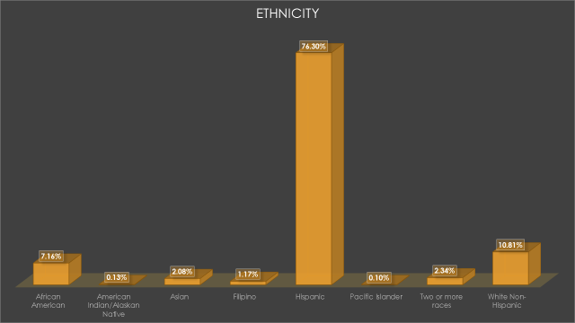

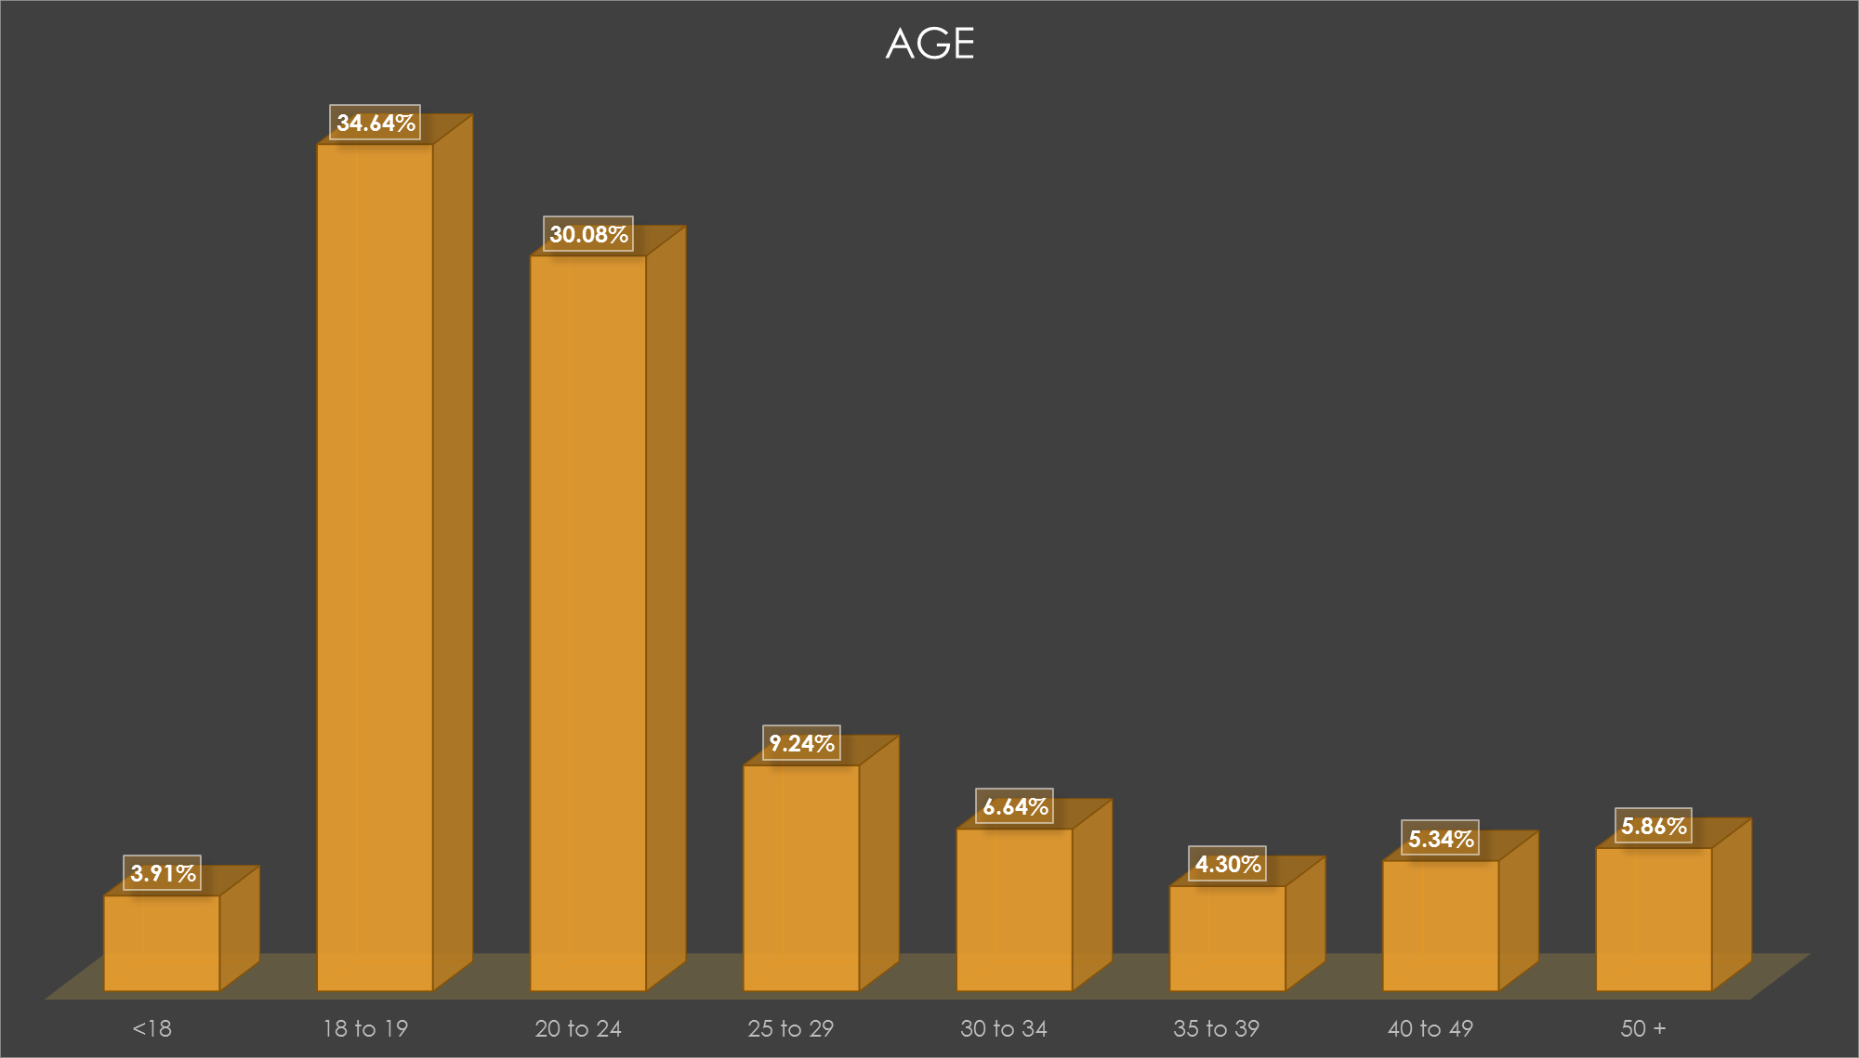

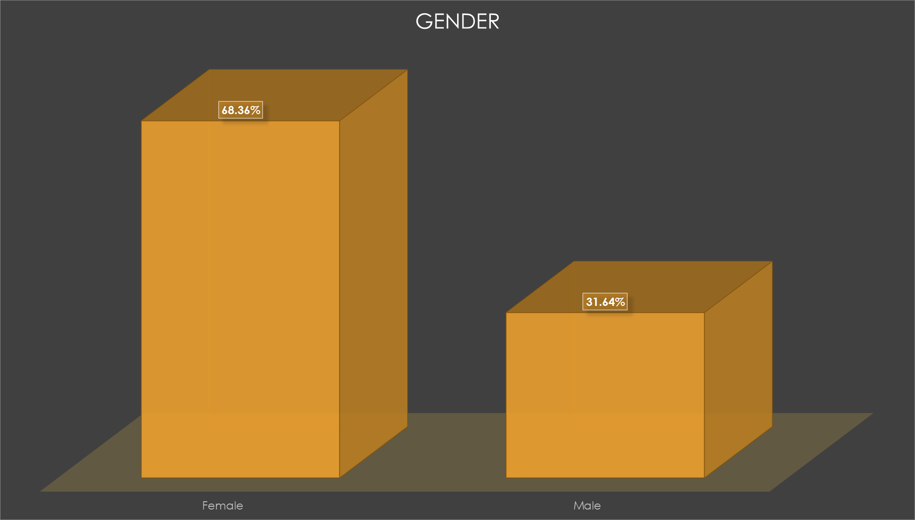

EOP&S Version 2.0 (Intervention and Student Support)
Currently, it is expected for the EOP&S program to serve 800 to 900 students (2015-2016). The program is aligned with the Student Equity Plan in serving the disproportionate impacted groups by providing a multitude of intrusive services.
- Foster Youth
- Veterans
- Economically Disadvantaged
- African American
- Hispanic Students
The goal is to increase by 1,000 the number of students served in the EOP&S program as well as incorporating academic support systems while maintaining the case management approach. Programmatic support services will include the following for all EOP&S students:
- Additional tutoring hours
- Supervised Study Areas
- Summer Bridges
- EOP&S Student Development Class
- Study Skills Workshops
- Technology assistance to students
- Summer EOP&S Jump Start Classes
Staffing:
Staffing will need to be in place to provide the mandated three contacts to EOP&S while increasing the students served. The following positions are proposed funded through equity:
- Full-Time EOP&S Counselor
- Full-Time Educational Advisor
- Full-Time Department Assistant II

Position | Funding Source | Program | FTE
Full Time EOP&S Counselor | Equity | EOP&S | 1
Full Time Educational Advisor | Equity | EOP&S | 1
Department Assistant II | Equity | EOP&S | 1

EOP&S 2.0
While focusing on the mission of EOP&S the emphasis will also be in assisting with the Student Equity plan in closing achievement gaps among the disproportionate impacted groups mentioned and who EOP&S serves. With the collaboration and funding from the Equity and Inclusion Office the EOP&S program will assist with the EOP&S student population in the following student success indicators:
Access:
- In collaboration assist in increasing the number of African American, Hispanic and Foster Youth students completing Comprehensive Student Educational Plans

ACTIVITES | PROGRAM
Develop and monitor Comprehensive Student Educational Plans for all EOP&S students | EOP&S
Engage in Outreach and Recruitment | EOP&S
Provide intrusive follow-up services to all EOP&S students | EOP&S
Incorporate EOP&S academic support services | EOP&S

Course Completion
- In collaboration assist in increasing African American and Hispanic course completion and 30 unit milestone
- In collaboration assist with increasing the 30 and 48 Unit Milestone attainment in underprepared and Hispanic Groups
ACTIVITIES | PROGRAM
Continue concerted EOP&S interventions;  - Progress Reports  - Early Alert  - Peer Mentoring  - Study Time  - Additional Tutoring | EOP&S
Provide Transfer workshop and transfer services to all EOP&S students | EOP&S
Continue to provide individualized intrusive support based on the EOP&S program curriculum:  - Academic  - Financial  - Social  - Personal | EOP&S

ESL and Basic Skills Completion
- In collaboration assist in increasing remedial English and Math success for African American and Hispanic Students
ACTIVITIES | PROGRAM
Incorporate and/or develop jump start math and English summer sessions for EOP&S students in basic skills | EOP&S
Continue to provide summer bridge sessions to incoming EOP&S students | EOP&S
Continue to provide at-rick interventions while incorporating new academic support interventions | EOP&S

Degree and Certificate Completion
- In collaboration assist in increasing the number of African Americans and Hispanic students achieving degrees/certificates
ACTIVITIES | PROGRAM
Develop units interventions at 30 and 48 units to align the CSEP with degree/certificate completion | EOP&S
Develop a Career Assessment inventory for all EOP&S students | EOP&S

Transfer
- In collaboration assist with increasing the transfer numbers of African American and Hispanic students
ACTIVITES | PROGRAM
Developing a tracking mechanisms to track EOP&S students who transfer | EOP&S
Increase the use of the transfer center and transfer activities for all EOP&S students | EOP&S
Increase the transfer workshops for all EOP&S students | EOP&S

Priorities:
Priority 1: Increase the EOP&S student population by 1,000 students (by increasing 1,000: 3,000 contacts will have to be made each semester)
Priority 2: Address the staffing needs to provide mandated EOP&S services
Priority 3: Develop, enhance and implement the academic support services
Priority 4: Provide EOP&S services to the disproportionate impacted groups as outlined in the Student Educational Plan

Additional Data:

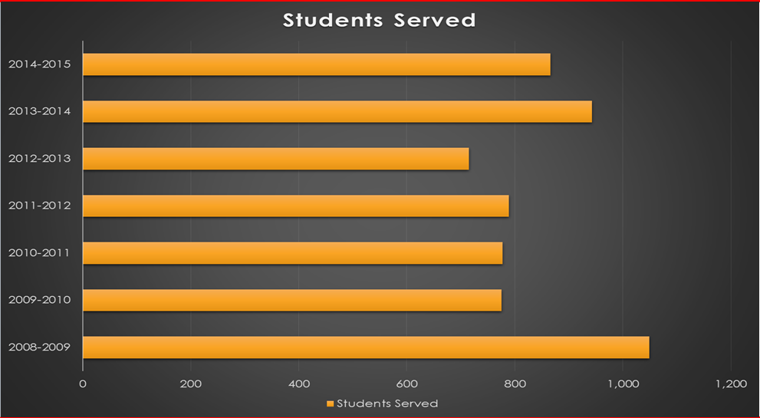

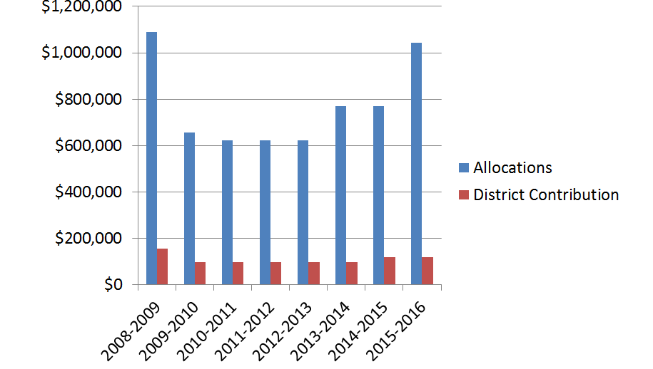

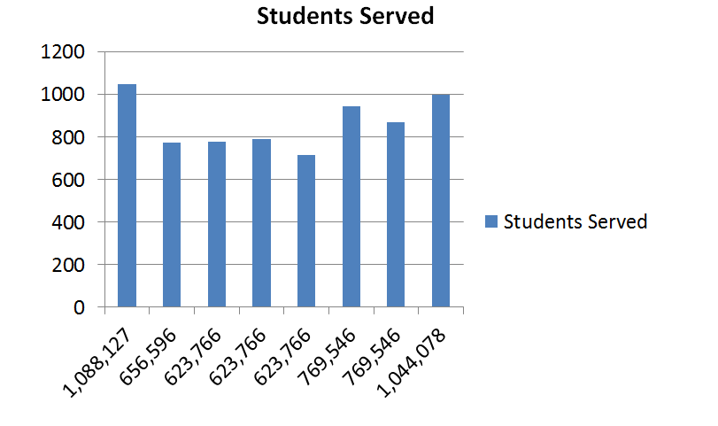

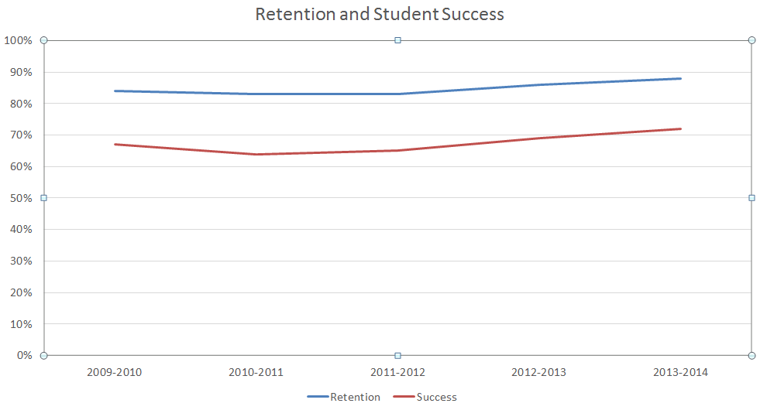

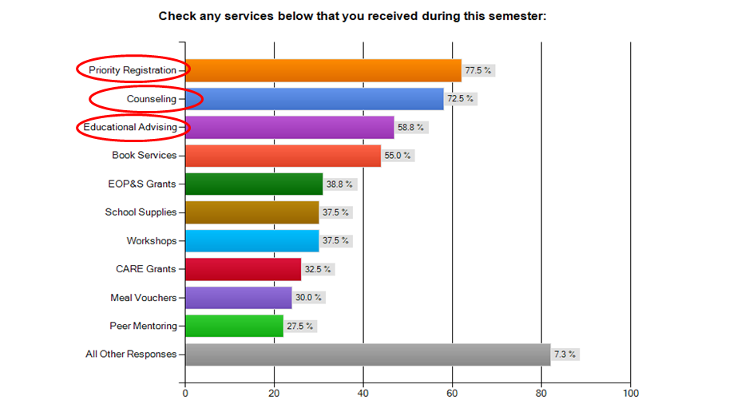

VII. Forms Checklist (place a checkmark beside the forms listed below that are submitted as part of the Annual Update):
Best Practices Form (Required)
Curricular Review Form (Instructional Programs Required)
Certificate Form (CTE Programs Required)
~~~~~~~~~~~~~~~~~~~~~~~~~~~~~~~~~~~~~~~~~~~~~~~~~~~~~~~~~~~~~~~~~~~~~~~~~~~~~~~~~~~~~~~~~~~~~~~~~~~~~~~~~~~~~~~~~~~~~~~~~~~~~~~~~~~~~~~~~
Faculty Request Form Classified Request Form Budget Form
Professional Development Form ISIT Form Facilities Form (Includes Equipment)

Other: ____________________

