Bakersfield College
Program Review – Annual Update 2016

I. Program Information:
Program Name: Music (a segment of the Performing Arts Department culminating in an ADT in Music or AA in Music [pre-2015 catalog rights])

Program Type: Instructional Student Affairs Administrative Service

Bakersfield College Mission: Bakersfield College provides opportunities for students from diverse economic, cultural, and educational backgrounds to attain Associate and Baccalaureate degrees and certificates, workplace skills, and preparation for transfer. Our rigorous and supportive learning environment fosters students’ abilities to think critically, communicate effectively, and demonstrate competencies and skills in order to engage productively in their communities and the world.

Describe how the program supports the Bakersfield College Mission: The Music program supports the college mission by providing “opportunities for students from diverse economic, cultural, and educational backgrounds to attain Associate ... degrees…, workplace skills, and preparation for transfer.” The program offers a wide array of music appreciation and music literature courses, such as history or appreciation of Western art music, appreciation of jazz, history of rock and roll, and a course about the music of world cultures, as well as genre specific performance ensembles. These courses address diversity directly, giving students an opportunity to explore many aspects of many cultural heritages. Also, the Music program is now in the second year (first and second co-hort) of offering an Associate Degree for Transfer (ADT), which includes a college funded individual lesson component (called applied music) that allows the program to better serve economically disadvantaged students pursuing a degree in music. The applied music program is a prime example of a “rigorous and supportive learning environment [that] fosters students’ abilities to think critically, communicate effectively, and demonstrate competencies and skills.” Many Music program graduates and former students have completed bachelor degrees and beyond, a number of whom now teach the next generation of young musicians here in Bakersfield and Kern County, showing their ability to “engage productively in their communities and the world.”

The Music program also advances the vision of Bakersfield College by contributing “to the intellectual, cultural, and economic vitality of the community it serves.”

Further, the Music program touches on many of the core values of Bakersfield College such as:
- Learning: The Music program clearly “fosters curiosity, inquiry, critical thinking, and creativity within a safe and rigorous environment.” And no one that has been to one of our choir concerts could deny the ability of those events to give “voice and power to all people.”
- Integrity: The very nature of group performance, whether it be vocal or instrumental, “places the collective wellbeing and health about the self.” Students learn to be accountable, not just for their own good, but for the good of the group. Such an environment also inevitably “teaches us to trust each other’s vision” as the group strives to communicate collectively the artistic intent of the composer and themselves.
- Wellness: Making music is a natural and healthy expression of emotion, a far more constructive channel for pent up emotion than so many destructive alternatives, improving “all aspects of the individual and the society including the mind, body, and spirit.”
- Diversity: The Music program’s diverse array of music appreciation courses covering Western art music, jazz, rock and roll, and most especially world music provide the “multiple perspectives [that] lead to a better education and knowledge of the world.” Additionally, our multi-cultural concert programming allows for “listening and witnessing different experiences” in ways that can expand the community’s capacity to embrace diversity.
- Community: A musical ensemble is a community in and of itself. However, though these ensembles and their performances “we maintain strong ties with the surrounding community.”

Program Mission Statement: The Bakersfield College Music program is an essential part of BC’s commitment to being a “comprehensive college.” Its mission is to provide multi-cultural learning and performance opportunities necessary for the aesthetic, intellectual, emotional, and cultural well-being of the college and its community by offering a wide variety of exceptional general education courses (Area C.1) and an Associate Degree for Transfer in Music, which includes as educational experiences high quality performances.

II. Progress on Program Goals:
- List the program’s current goals. For each goal (minimum of 2 goals), discuss progress and changes. If the program is addressing more than two (2) goals, please duplicate this section.

Program Goal | Which institutional goals from the Bakersfield College Strategic Plan will be advanced upon completion of this goal? (select all that apply) | Progress on goal achievement  (choose one) | Comments
1. Add fulltime classified position of stage manager/theatre technician | 1: Student Learning  2: Student Progression and Completion  3: Facilities  4: Oversight and Accountability  5: Leadership and Engagement | Completed: Spring, 2016  Revised: _______ (Date)  Ongoing: _______ (Date) | This completed goal, shared with Performing Arts Department sister program Theatre, will enable both programs and the college/community at large to use the SPArC more effectively and safely, improving student success, play and concert quality, and community satisfaction with the venue(s). This will also mean better oversight of the investment in the renovation of the space.
2. Complete the curriculum for and begin offering a Commercial Music Certificate of Achievement (CA) | 1: Student Learning  2: Student Progression and Completion  3: Facilities  4: Oversight and Accountability  5: Leadership and Engagement | Completed: Spring, 2016  Revised: ________ (Date)  Ongoing: ________ (Date) | This goal, now complete, will continue to be tracked as a separate CTE program review beginning this year. In the fall semester 2016, three of the six required courses for certificate are in the schedule and in high demand with students, with two additional courses planned to start in spring, 2017. The entire sequence will be offered over a 3-4 semester span. The only remaining hurdle (hoop to jump through) is a substantive change proposal filed with ACCJC (if requested).
3. Add fulltime tenure track position in instrumental music that meets Music minimum qualifications (Master's degree in Music) | 1: Student Learning  2: Student Progression and Completion  3: Facilities  4: Oversight and Accountability  5: Leadership and Engagement | Completed: Summer, 2016  Revised: ________ (Date)  Ongoing: ________ (Date) | Kathryn Kuby, DMA joined the faculty as of this fall, 2016 and has taken over responsibility for the orchestra and concert band programs and is also teaching multiple high-enrollment general education sections. Already enrollment and morale for the ensembles have risen, though the full positive impact of this change will take multiple semesters or years to come to fruition.

- List new or revised goals (if applicable)

New/Replacement Program Goal | Which institutional goals will be advanced upon completion of this goal? (select all that apply) | Anticipated Results
1. Add fulltime tenure-track position in Jazz Studies | 1: Student Learning  2: Student Progression and Completion  3: Facilities  4: Oversight and Accountability  5: Leadership and Engagement | - Improved quality and visibility of current program.  - Increased interaction with and student transfers to CSUB and other institutions with strong jazz studies programs.  - Increased interaction with and recruitment from high school jazz programs.  - Increased FTES through additional staffed general education courses.  - Increased AAT completions by serving a student population currently not served by the existing "classical music" oriented program, making our program even more inclusive.  - May serve as an equity initiative.
2. Continue the process of replacing broken, obsolete, and missing instructional equipment and instruments, including a music filing system for the instrumental music program. | 1: Student Learning  2: Student Progression and Completion  3: Facilities  4: Oversight and Accountability  5: Leadership and Engagement | - Improved student learning using appropriate instruments and equipment. For example, students cannot learn keyboard technique using a keyboard with stuck keys, as is currently true for all of our practice room electronic keyboards.  - Improved and more efficient use of facilities. Currently there are six practice rooms in the FA building that house broken keyboards. Not surprisingly, these spaces are significantly under-utilized, resulting in music majors competing for the few available practice rooms in the SPArC and having access to insufficient practice time.  - Improved use of available resources through organizing and identifying the content of the current instrumental music library. This library currently consists of well over 20 individual metal filing cabinets, some dating back to when the campus was built. Many of these cabinets are permanently locked because the keys to them have been lost over the decades. All of this music, if purchased today, would cost tens of thousands of dollars. Any of it that remains usable should be identified and stored appropriately. There is a choral library, complete with a Wenger music storage system that was part of the SPArC renovation project (too small for our existing choral library, but it's a start). No such provision was made for instrumental music, no doubt because the instrumental programs did not have fulltime faculty support when the renovation plans were made. This staffing issue has now been rectified, but staffing alone cannot ensure a strong program without also addressing long-standing deficiencies in organization and maintenance of materials, instruments, and equipment.

III. Trend Data Analysis:
Highlight any significant changes in the following metrics and discuss what such changes mean to your program.
- Changes in student demographics (gender, age and ethnicity).

The Music program persists as a popular choice for male students, which has been a constant over the last 5 years. During the previous year, the gender difference for the Music program was almost exactly opposite of the college at large with males outnumbering females 55% to 45% compared to the college population of 55% female and only 45% male. However, this gap shrank for the Music program in 15-16 to a nearly equal 52% male/48% female--still atypical for the campus.
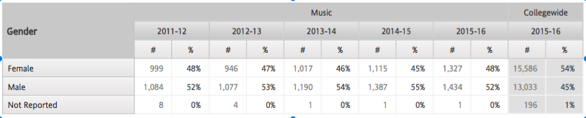

The Music program population is also skewed significantly toward the 19 and younger and 20-29 year-old population (recent high school graduates) as compared with the college at large. Over the last 5 years, 90% or more of music students fall into these two categories, as opposed to only 79% collegewide in 2015-16. In particular, nearly half of the music program's students (47%) are 19 and younger as compared to only just over a quarter of the college at large (28%). This too, has implications for success and retention, for though this young demographic retains at a slightly higher rate in the program compared to collegewide (19 and under--88% to 87%; 20-29--85% to 84%), the Music program succeeds with this demographic at a significantly higher rate (19 and under--70% to 65%). Music courses often involve interactive learning combined with a sense of belonging, as in the case of performing ensembles. This may account for both the attraction of younger students to the program and for their relatively higher success rate in it.
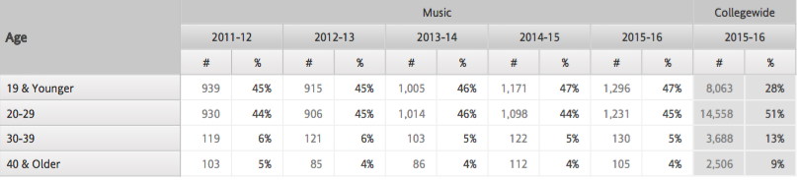
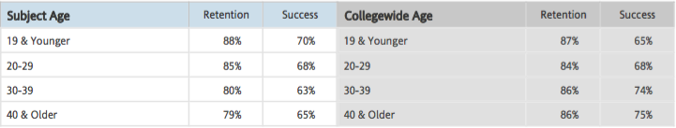

As for ethnicity, the Music program almost perfectly mirrors the collegewide distribution, retention, and success rates for each identified group. The slightly lower numbers for retention and success for American Indian students is likely a product of such a small sample size (6 students).

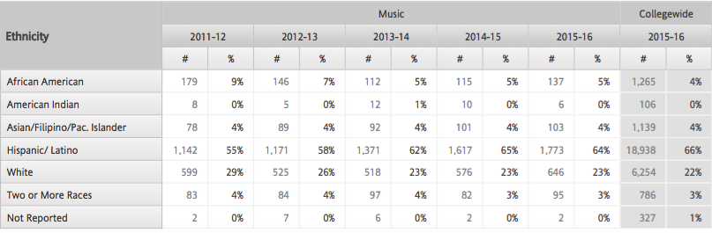
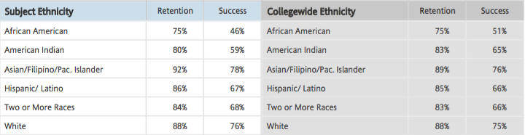

- Changes in enrollment (headcount, sections, course enrollment and productivity).

2,762 unduplicated students, or 9.6% of all students at Bakersfield College, took a music class in 2015-16. 2,762 is 10% higher than 2014-15, which was 13% higher than 2013-14, which was 9% higher than 2012-13. The college has supported this growth with additional positions and resources (or perhaps the reverse). The number of sections of music classes increased by 14.6% to 94 in 2015-16. This increase reflects mainly additional general education course sections. Students per section in 2015-16 remained steady at 41. FTES increased 12.3% over 2014-15 to 392.7. However FTEF also grew substantially from 18.5 to 23.2, an increase of 25.4% resulting in a drop in productivity. However, productivity of 16.9 FTES/FTEF remains higher than the collegewide face-to-face average of 16.8 (our program does not offer online instruction so this compares apples to apples).

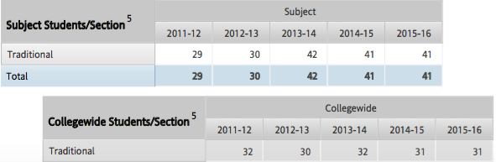

- Success and retention for face-to-face, as well as online/distance courses.

The Music program does not offer distance education courses, but our program success and retention numbers track almost identically with the campus average for face-to-face instruction (Program retention--89% vs. College retention--88%; Program success--71% vs. College success--71%).

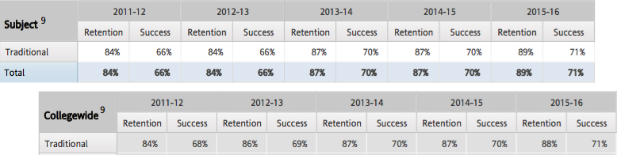

- Other program-specific data that reflects significant changes (please specify or attach). All Student Affairs and Administrative Services should respond.

An important area to draw the reader's attention to is the Music program's major improvement in degree completion over recent years. In 2015-16, the program graduated 9 students (6 AAs and 3 AA-Ts)--an increase of 80% over the previous year. This is almost completely attributable to the Applied Music (individual lessons) component required for the Music AA-T. The Applied Music program requires students receiving lessons to be concurrently enrolled in other major required courses, leading to more consistent completion of those courses. The applied course (MUSC B7) also requires research on key goal-setting topics such as financial aid, transfer institutions, scholarship interviews, and audition protocol as course assignments--in addition to building the individual instrumental or vocal skill of each student.
NOTE: The numbers shown for degree attainment are incorrect on the district's Trend Data Page because students that earn degrees in more than one subject are assigned to only one department (in alphabetical order?). Therefore the student that earned both the AA-T in Music and the AS-T in Mathematics, for example, does not appear in the table below. The number of degrees mentioned above (6 AAs and 3 AA-Ts) was confirmed for each individual student through transcript review.

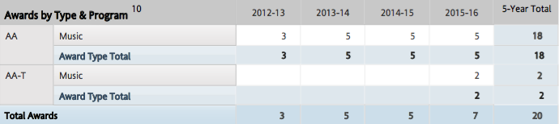

IV. Program Assessment (focus on most recent year):
Use attached Assessment Report Form AU Tab

- Describe any significant changes in your program’s strengths since last year.
We have built upon our strengths to include:
- Diverse, high quality public performances: Choir, Band, Jazz Ensemble, Drum Line (WGI), Orchestra, Drum and Bugle Corps (DCI) the addition of student solo recitals (applied music) and the addition of a return of the Renegade Marching Band.
- C-ID approval of all ADT required courses resulting in a very high degree of articulation with the CSU system.
- Use of instructional technology has expanded to apply to all offered courses in some way. Particularly impacted in a positive way are the piano courses (MUSC B5AB) and the music lab courses (MUSC B230ABC) due to the new equipment acquired as part of the SPArC remodel. This equipment will also benefit the ensemble performance courses now housed in the SPArC.
- Retention, success, and productivity data well above the college average (see data discussion).
- Highly engaged faculty in campus and community initiatives (Mission review, ILO development, Accreditation, Academic Senate, Music Association of California Community Colleges [MACCC}, C-ID, Kern County Music Educators Association [KCMEA], CSUB, feeder high schools, Bakersfield Symphony and Youth Symphony, etc.).
- A thriving applied music course that currently consists of 45 auditioned students supported by more than 15 faculty. These students are also required to participate in a performing ensemble and in music theory courses in order to qualify for the program, thereby increasing the efficiency and quality of these courses.
- Addition of Commercial Music Certificate of Achievement, with courses beginning this fall. Student demand is strong for these courses.
- Addition of a fulltime, tenure-track instructor to conduct the Concert Band and Orchestra, eliminating a weakness noted in last year's document.
- Addition of a fulltime, tenure-track instructor to lead the marching arts program (instead of temporary fulltime), eliminating a weakness noted in last year's document.
- Addition of a fulltime technical theatre staff member, eliminating a weakness noted in last year's document.

- Describe any significant changes in your program’s weaknesses since last year.
We are making headway in addressing our weaknesses as outlined in last year’s document, in some cases with requests in this year’s document. Here are the weaknesses we previously identified with a summary of our progress.
- Lack of fulltime faculty members responsible for instrumental music program--SOLVED!
- Need for fulltime theatre technical staff to support music, theatre, and outside events in SPArC--SOLVED!
- Low graduation rate--IMPROVED! (see data review above)
Newly identified weaknesses
- Lack of fulltime faculty to lead a Jazz Studies program. Jazz is a respected and distinct sub-discipline of music. Most universities that offer a music degree offer coursework and often a separate degree in Jazz. For example, CSUB's music program has a history of a very strong jazz program. At BC, however, the only support for jazz is a single ensemble course and a general education survey Jazz Appreciation course, all taught by an adjunct faculty member. In order for the BC Music program to be complete, support for jazz education needs to be elevated. Some aspects of such elevation might include: jazz performers receiving lessons in jazz performance as part of the Applied Music program; jazz combo instruction; courses in improvisation; jazz history courses (more in-depth than appreciation), multiple jazz ensembles (an "A" band and a "B" band) with higher skill/audition expectations. Such improvements would further solidify the good reputation of the program overall and improve recruitment of high quality music majors.
- Instructional equipment needs to be replaced (instruments and classroom instructional technology).
- Instrumental ensembles need to continue to grow in size and quality. With the hiring of Dr. Kathryn Kuby to conduct the Concert Band and College Orchestra and Tim Heasley as a tenure-track faculty member to lead the marching arts ensembles (no longer temporary!), we have changed these weaknesses into strengths. However, some of these programs still need time and resources to help them to grow and strengthen. This will require active recruiting by these faculty and institutional support. Building a good reputation takes time, but we are definitely on our way.
- Facility improvements needed. Some weaknesses in the usability of the SPArC as renovated could not be anticipated. For example, several practice rooms were placed in the Theatre Scene Shop--seemingly benign choice at the time. However, this placement interferes with the operation of the scene shop and the units are often inaccessible to music students due to locked outer doors to secure the tools and materials in the shop (these practice rooms are also very secluded, which has other inherent dangers). These modular practice rooms need to be relocated to more appropriate locations. Also, just as the new Commercial Music program is coming on-line, it has already out-grown its current classroom space in PAC 115. Additional space for this program must be allocated in order for it to function as intended.

- If applicable, describe any unplanned events that affected your program.

Not Applicable.

V. Assess Your Program’s Resource Needs: To request resources (staff, faculty, technology, equipment, budget, and facilities), please fill out the appropriate form. https://committees.kccd.edu/bc/committee/programreview

- Human Resources and Professional Development:
- If you are requesting any additional positions, explain briefly how the additional positions will contribute to increased student success. Include upcoming retirements or open positions that need to be filled.
We are requesting an additional fulltime faculty position in Jazz Studies. This position will provide support for students intending to transfer as jazz studies majors (a sub-category of a Bachelor of Arts or Bachelor of Music degree) and will increase general education offerings. Filling this void will increase student success by providing jazz students access to a faculty member during day hours and throughout the week. Currently, jazz students only have access to the ensemble director (who is adjunct) at the evening rehearsals and before and after scheduled class meetings. Additionally, this individual would be tasked with coordinating with high school feeder programs to recruit students and publicize our program. He/She would also (optimally) have their office in the SPArC, providing additional supervision and security for the facility. Faculty with expertise in Jazz frequently have cross-over skills in Commercial Music. This additional faculty member may well support that growing program as well.
- Professional Development:
- Describe briefly the effectiveness of the professional development your program has been engaged in (either providing or attending) during the last year, focusing on how it contributed to student success.
John Gerhold continues to serve as an executive officer of MACCC (Music Association of California Community Colleges). As a result of being able to attend the annual conference, Dr. Gerhold was called upon to work directly with the ASCCC (Academic Senate of California Community Colleges) and the CCC Chancellors Office on issues related to the Music TMC and continues to serve as a resource for BC and statewide community college music faculty on issues ranging from music curriculum development, the Music ADT, and C-ID certification of music courses. This serves student success by helping to ensure that BC's programs offer the curriculum expected by the state and that the curriculum is fully articulated with our transfer partners in the CSU system.

- What professional development opportunities and contributions can your program make to the college in the future?
Contact “with the outside world” remains an important resource to the continued success of the Music program. Continued participation with MACCC, ACDA, and other regional and national associations keeps the faculty abreast of innovations and changes in regulations, allowing the program to keep current and best serve students. Particularly important is providing these opportunities to the new faculty. Josh Ottum can use information and networking that occurs at the MACCC conference to continue to build and improve the Commercial Music program. Kathryn Kuby, new to community college teaching, can definitely benefit from interacting with other community college orchestra and concert band directors at the MACCC conference, learning aspects of program development and recruiting that would take years to learn in a vacuum. As far as contributions the Music program makes to the college goes, Jennifer Garrett, Tim Heasley, Kathryn Kuby, and Kris Tiner all make themselves and their student ensembles available to the college to support various initiatives, meetings, and events with energizing and uplifting music. Additionally, concerts held in the SPArC Indoor/Outdoor Theatre serve the cultural needs of students, staff, faculty, and the community.

- Facilities:
- How have facilities’ maintenance, repair or updating affected your program in the past year as it relates to student success?
Student success has been greatly enhanced due to the new furniture installed in FA 65 and FA 60, our primary lecture rooms (thanks Andrea Watson!). These spaces still need technology upgrades, however (see below). Custodial support for the PAC has improved immensely with whatever current staffing solution exists, further improving the educational environment for students. Thanks also for repairing the roof over the electric switch room in the Outdoor Theatre, this will protect the equipment and music we store in this space, though some of it was already water damaged from the leak.
- How will your Facilities Request for next year contribute to student success?
We are requesting support to improve student access to the practice rooms currently housed in PAC 1, the scene shop. These practice rooms can only be accessed if a staff member with a key is present to open the outer door. Also, these rooms are very secluded which may encourage behavior that depends upon such seclusion rather than actual practicing. Our plan is to move these units to the band room, the recording studio, or perhaps one to each location. This will likely involve support from Wenger (the original vendor). Further, we are requesting re-allocation of the "reception room" near the lobby of the SPArC as a space for the growing recording arts program. This room was originally a recording studio when the building was built in 1955 and is still identified as such on the current plans. PAC 115 is simply too small to serve as a keyboard and music software teaching facility and as a recording studio. Further, PAC 115 has serious sound bleed-through problems making it a very problematic space in which to record. We will also need support from M&O to implement a music storage system in the band room PAC 2. Currently this room contains literally dozens of metal file cabinets, many of which have been permanently locked for decades due to lost keys, etc. This will require an equipment allocation also (probably from Wenger as well).

C. Technology and Equipment:
- Understanding that some programs teach in multiple classrooms, how has new, repurposed or existing technology or equipment affected your program in the past year as it relates to student success?
No changes in the past year. Existing technology equipment in FA 60 and FA 65 is central to the success of students taught in those spaces (more than 1300 enrollments per semester).

The COW (computer on wheels) in FA 60 is problematic, though. It takes up a huge space that could be filled with students instead. It interferes with sightlines from some areas of the room making the instructor and/or the screen difficult to see. The 40-year old screen in the room no longer retracts, rendering the primary chalkboard space unusable. The power cord for the unit is also a tripping hazard. This needs to be addressed.

In FA 65, the switching unit and other AV components in the cabinet are on their last legs, as is the ceiling-mounted projector. As with the COW in FA 60, these items need to be replaced. This will necessitate replacing the chalkboards with white boards. All of the whiteboards in both rooms should be lined for music notation except for the single section used as a screen for a short-throw projector.

- How will your new or repurposed classroom, office technology and/or equipment request contribute to student success?
The Music program is the primary user of FA 65 and FA 60. These two classrooms host media intensive coursework and yet have very antiquated equipment. FA 65 uses an old ceiling mounted projector use for showing concert video, films, etc. This system needs to be replaced, preferably with a similar system, since the room is large and images from a wall mounted, short-throw projector are rather small. FA 60 is making do with a "COW" (computer on wheels). Again, the nature of the instruction that takes place in this room is media intensive. High quality sound and images are essential to student success. Each of these rooms serves classes of 60 or more students per section. Upgrades to the rooms will serve as many as 1380 students PER WEEK during a typical instructional week.
PAC 8 and 2 (band room and choir room respectively) still need work on the sound systems connected to the installed computers. Remember, these are music teaching spaces--high quality sound is ESSENTIAL for student success.
- Discuss the effectiveness of technology used in your area to meet college strategic goals.
1: Student Learning Students learn better in an environment where the equipment works and addresses their learning styles. Assessment has revealed the importance of visual presentation of musical information to improve student success.
2: Student Progression and Completion Technology equipment is central to student success in completing the ADT in Music--especially in the PAC 115 Music Lab, but also in the rehearsal rooms (PAC 02 and 08) and the academic classrooms (FA 65 and 60).
3: Facilities Proposed software solutions intended to improve the scheduling of the campus facilities (including the SPArC) will help to maintain that facility. Currently Jennifer Garrett manually maintains the music and theatre calendars and assists the Events Planning Office with this task.
4: Oversight and Accountability As mentioned above, the software solution for scheduling will allow for better oversight and accountability.
5: Leadership and Engagement Technological support allows the Music program to do what it does best--engage the community and present a high-quality, positive image for the college through concerts, festivals, and presentations for our students, staff, faculty, and community.

D. Budget: Explain how your budget justifications will contribute to increased student success for your program.

The bulk of our budget requests involve instructional equipment, both new equipment for the commercial music program and replacement equipment for existing performance groups and classrooms. We have already seen how a first class facility contributes to student success. However, it is both limiting and demoralizing to work in a first class facility with 60 year old, broken, past-its-useful-life instruments and tools. We built a building that can become a focal point of the Bakersfield Community. We cannot build programs worthy of that space using the decrepit equipment that was purchased in 1955 for the building when it was new.

We will be requesting a similarly large operating budget in 2017-18. Our 2015 Annual Update included a request for significant increases to support the program, some of which was funded. Here is an excerpt from our 2015APR showing our rationale for reasonable requests. The actual funding provided in 2016-17 is shown in square parentheses [ ].

"In particular we need an increase to the instrument repair and tuning account (5690) to extend the useful life of the $130,000 in new pianos purchased for the SPArC (6 pianos total, including a new Steinway B Grand). The remaining pianos in our fleet have an average age of more than 30 years each (several are more than 50 years old). Instruments of this age should simply be replaced, but this would cost another $400,000-500,000. Since we can assume this is cost prohibitive, tuning and repair becomes all the more important. Two tunings per semester for each of the 11 pianos in the fleet requires a tuning budget of $4400 per year. This is the same account used to maintain band and orchestra instruments. Due to the age of our current set of instruments, we can expect to spend another $2000 maintaining these, totaling $6400 for the year." [total budget for 2016-17 $3000]

"Also, now that we are back in our native habitat—a music/theatre building—we are back to full strength in terms of ensembles with two choirs, concert band, jazz ensemble, orchestra, and drumline (with seasonal ensembles of Marching Band and Drum and Bugle being added this year). Each of these groups needs music to perform (photocopying is illegal, after all). A reasonable music budget for each group is $800 a year, for a total of $6400. This, added to funds for instructional supplies (white board markers, etc), makes a round $7000 in the 4310 account for supplies." [total budget for 2016-17 $4600]

With the reinstatement of the College Orchestra comes the critical need for replacement orchestral percussion instruments, given that most of the current instruments were purchased for the original construction of the SAM building in 1955. A set of 5 timpani ($16,529 top priority), xylophone, vibraphone, bass drum, chimes, glockenspiel, concert snare, and piati (concert cymbals) will total more than $22,000. This total could be spread across several years, though the timpani will need to be purchased all at once.

"For the Jazz Ensemble program specifically: The Jazz Ensemble would like to purchase a bass trombone. This is an essential instrument in the published repertoire, but one that students rarely own. Purchasing a bass trombone for the program will enable us to fully flesh out the ensemble sound and achieve a true “big band” orchestration. Getzen 1062FD Eterna Series Bass Trombone - $3355 http://www.wwbw.com/Getzen-1062FD-Eterna-Series-Bass-Trombone-464533-i1436781.wwbw Fender Standard Jazz Bass Guitar - $599 http://www.musiciansfriend.com/bass/fender-standard-jazz-bass-guitar
Instrumental Music Folders - 75 x 11.95 = 896.25 https://www.jwpepper.com/Model-3501-Instrumental-Folder/2047231.item#.VfHFg2A-Bqw
[total requested over $40,000; total budgeted for 2016-17 $25,000]
While it is definitely heartening to have had some of our needs recognized and funded this year, additional needs continue to surface even as past requests are under-funded. Such a formula clearly leads in the wrong direction.
Our newly hired concert band and orchestra director has indentified additional needs which include: a conductor's podium-$900; a music filing system- ; an alto saxophone-$1500; a bass clarinet-$3000; a bassoon-$3000; a trombone-$2500; a French horn-$2500; a tuba-$8000; and a euphonium-$4000.
VI. Conclusions and Findings:
Present any conclusions and findings about the program. This is an opportunity to provide a brief abstract/synopsis of your program’s current circumstances and needs.

The BC Music program is growing and improving at an amazing rate, as a result of the infusion of new, dynamic faculty and the inspiration of our beautiful facility. Thanks are definitely due to President Christian and her team for supporting the development of the ADT in Music and giving our program an opportunity to grow. Such progress makes us all the more impatient to see our program truly meet its potential. This will require significant additional resources, but with our success comes also an opportunity for the college to benefit from the positive reaction of the community to our public performances. As we consider placing a bond issue before the voters in the future, the Music program can be a powerful vehicle for underscoring the quality of BC throughout the surrounding community.

VII. Forms Checklist (place a checkmark beside the forms listed below that are submitted as part of the Annual Update):
Best Practices Form (Required)
Curricular Review Form (Instructional Programs Required)
Certificate Form (CTE Programs Required)
~~~~~~~~~~~~~~~~~~~~~~~~~~~~~~~~~~~~~~~~~~~~~~~~~~~~~~~~~~~~~~~~~~~~~~~~~~~~~~~~~~~~~~~~~~~~~~~~~~~~~~~~~~~~~~~~~~~~~~~~~~~~~~~~~~~~~~~~~
Faculty Request Form Classified Request Form Budget Form
Professional Development Form ISIT Form Facilities Form (Includes Equipment)

Other: Other Equipment Form
Other: Assessment Form

