Bakersfield College
Comprehensive Program Review

I. Program Information:
Program Name:

Program Type: Instructional Student Affairs Administrative Service

Bakersfield College Mission: Bakersfield College provides opportunities for students from diverse economic, cultural, and educational backgrounds to attain Associate and Baccalaureate degrees and certificates, workplace skills, and preparation for transfer. Our rigorous and supportive learning environment fosters students’ abilities to think critically, communicate effectively, and demonstrate competencies and skills in order to engage productively in their communities and the world.
Describe how the program supports the Bakersfield College Mission:
Career and Technical Education: Students have the opportunity to obtain a Certificate of Achievement or an Associate of Science degree. These involved students select these courses from the Construction Technology area and/or from the various related departmental programs (Industrial Drawing, Architecture, Wood Technology and Industrial Technology). Many students from other disciplines (i.e. architecture, wood working and etc.) also take various construction courses to enhance their related professional growth.
Transfer: Introduction to Construction and Estimating, Print Reading & Scheduling courses are transferable. Furthermore many transferring students in the architecture, industrial drawing, construction management and wood working programs find that the various construction courses and related construction experience complements their personal professional growth.
Basic skill: The construction program recognizes that many of the involved students are deficient in basic math, reading, writing and workforce preparation skills. Recognizing this, much of the instruction is self-paced and modularized. Students needing further basic skill support are encouraged to seek support from services within the college.
Program Mission Statement:
The construction program supports the many diverse construction occupations within the County of Kern’s five main construction sectors (Residential, commercial, industrial, heavy civil and environmental construction sectors). Because of Kern County’s rising need for skilled construction personnel, the Construction Technology program is dedicated to provide involved students with the opportunity to develop skills and knowledge for enter into these construction sectors. Emphasis is placed on blending technical skill development with practical lab exercises.
The construction program and related staff strive to offer relevant, current and student centered instruction. Instructors are also sensitive to the diversity of our students, their educational needs, and their career goals. To accommodate our diverse student population, much of the instruction is modularized, interactive and self paced. The construction staff is also sensitive in assisting each student to define their specific career goal.

Instructional Programs only:
- List the degrees and Certificates of Achievement the program offers
- If your program offers both an A.A. and an A.S. degree in the same subject, please explain the rationale for offering both.
- If your program offers a local degree in addition to the ADT degree, please explain the rationale for offering both.

II. Progress on Program Goals, Future Goals, and Action Plans:
- List the program’s current goals. For each goal (minimum of 2 goals), discuss progress and changes. If the program is addressing more than two goals, please duplicate this section.
Current Program Goals | Which institutional goals from the 2015-2018 Strategic Directions for Bakersfield College will be advanced upon completion of this goal? (select all that apply) | Progress on goal achievement  (choose one) | Comments
1. Improve student retention | 1: Student Learning  2: Student Progression and Completion  3: Facilities  4: Oversight and Accountability  5: Leadership and Engagement | Completed: __________ (Date)  Revised: __________ (Date)  Ongoing: __5/2016__(Date) | Retention and success rates have improved but more work remains to be done. Further improvement should occur as curriculum is revised.
2. Revise program curriculum to focus on construction management | 1: Student Learning  2: Student Progression and Completion  3: Facilities  4: Oversight and Accountability  5: Leadership and Engagement | Completed: __________ (Date)  Revised: __________ (Date)  Ongoing: __________ (Date) | Some initial discussions took place involving ARCH and INDR faculty, however the new CNST faculty member will be instrumental in this effort.

- List the program’s goals for the next three years. Ensure that stated goals are specific and measurable. State how each program goal supports the College’s strategic goals. Each program must include an action plan.
Future Goals | Which institutional goals from the 2015-2018 Strategic Directions for Bakersfield College will be advanced upon completion of this goal? (select all that apply) | Action Plan | Timeline for Completion | Lead person for this goal
1. Redesigning the construction courses to be modular and worth 3 units, instead of the current 7 unit courses. | 1: Student Learning  2: Student Progression and Completion  3: Facilities  4: Oversight and Accountability  5: Leadership and Engagement |  |  | Max Pena
2. Develop an on-campus construction worksite lab to provide real-world experiences for construction and architecture students. | 1: Student Learning  2: Student Progression and Completion  3: Facilities  4: Oversight and Accountability  5: Leadership and Engagement |  |  | Max Pena

III. Trend Data Analysis:
Review the data provided by Institutional Research. Provide an analysis of program data throughout the last three years, including:
- Changes in student demographics (gender, age and ethnicity).
Gender: The percentage of female students has increased over the past three years: 6% in 2013-14, 9% in 2014-15, and 12% in 2015-16. The percentages were 16% in 2011-12 and 10% in 2012-13, years with higher enrollments. The possible reasons for this are unclear, however, efforts will be made to continue the upward trend in the percentage of female students. The development of the program into a construction management focus may help with this goal.
Age and Ethnicity: The percentages for these two areas very closely follow the college-wide statistics.
- Changes in enrollment (headcount, sections, course enrollment, and productivity).
Headcount: The unduplicated headcount increased from 67 in 2013-14 to 90 in 2015-16. The program is seeing enrollment growth trend.
Sections: The number of course sections offered has remained a consistent four per year since 2012-13. The residential construction classes, CNST B50A and B50B, are 7 unit lecture-lab courses that meet for 15 hours per week per semester – B50A in the fall, B50B in the spring. One section represents the entire teaching load for the sole full-time construction instructor.
Course Enrollment: First day enrollment has increased from 86 in 2013-14 to 117 in 2015-16. During this period the students per section remained relatively steady at 22, 22, and 23, indicating consistent demand for classes in construction.
Productivity: FTEF/FTES has increased steadily from 9.8 in 2013-14 to 11.6 in 2015-16. An adjunct instructor was hired in 2015-16 to teach the evening class sections of CNST B1 “Introduction to Construction” and CNST B2 “Estimating and Budgeting”.

- Changes in achievement gap and disproportionate impact.

 | Retention |  |  | Success
Ethnic Group | CNST | BC | ∆ (CNST-BC) | CNST | BC | ∆ (CNST-BC)
African American | 66% | 75% | 0% | 29% | 51% | +17%
American Indian | 100% | 83% | +17% | 100% | 65% | +35%
Asian/Filipino/Pacific Islander | 75% | 89% | -14% | 50% | 76% | -26%
Hispanic/Latino | 80% | 85% | -5% | 85% | 66% | +19%
Two or More Races | 84% | 83% | -1% | 58% | 83% | -15%
White | 80% | 88% | -8% | 69% | 75% | +6%

- Success and retention for face-to-face as well as online/distance courses.

 | 2013-14 |  |  | 2014-15 |  |  | 2015-16 |  |  | Overall
 | CNST | BC | ∆ (CNST-BC) | CNST | BC | ∆ (CNST-BC) | CNST | BC | ∆ (CNST-BC) | CNST | BC | ∆ (CNST-BC)
Retention | 78% | 87% | -9% | 62% | 88% | -16% | 79% | 88% | -9% | 78% | 85% | -7%
Success | 53% | 70% | -17% | 53% | 69% | -16% | 70% | 71% | -1% | 59% | 68% | -9%

- Degrees and certificates awarded (three-year trend data for each degree and/or certificate awarded).

Full Name of Degree or Certificate | 2011- 2012 | 2012- 2013 | 2013- 2014 | 2014- 2015 | 2015- 2016 | 2016- 2017
Certificate of Achievement – Construction Technology |  | 1 | 3 | 1 | 1 | 4

- Other program-specific data (please specify or attach).
- List degrees and certificates awarded (three-year trend data for each degree and certificate awarded). Include targets (goal numbers) for the next three years.

Full Name of Degree or Certificate | 2011- 2012 | 2012- 2013 | 2013- 2014 | 2014- 2015 | 2015- 2016 | 2016- 2017
Certificate of Achievement – Construction Technology |  | 1 | 3 | 1 | 1 | 4

IV. Program Assessment:
Use attached Assessment Report Form Comprehensive Tab

- Discuss your program’s strengths.
- In 2015-16 the lead instructor announced his retirement. A replacement was hired who has 11 years of prior full-time experience teaching construction at Long Beach City College, 3 years as an adjunct instructor at El Camino College, and many years as a building contractor. He comes to BC with experience in curriculum development.
- Last year the decision was made to revise the construction technology program to focus on construction management. This is supported by data from EMSI and Cal-PASS-Plus LaunchPad which show an annual need of 95-120 first-line construction supervisors in the Kern County area.
- Discuss your program’s weaknesses.
- As previously mentioned, the core classes for the program are CNST B50A and B50B. These are lecture/lab classes that are 7 units and meet for 15 hours per week. This creates inflexibility in scheduling for students and the lead instructor of the program. The new instructor will be developing new modular courses, each being 3 or 4 units to allow more flexible scheduling for day and evening students.
- If applicable, describe any unplanned events that affected your program.

V. Resource Analysis: To request resources (staff, faculty, technology, equipment, budget, and facilities), please fill out the appropriate form. https://committees.kccd.edu/bc/committee/programreview

- Human Resources and Professional Development:
- If you are requesting any additional positions, explain briefly how the additional positions will contribute to increased student success. Include upcoming retirements or open positions that need to be filled. This position provides vital support the programs that comprise the department – architecture, automotive technology, construction, engineering, industrial drawing, manufacturing, welding, woodworking. The technician maintains and repairs equipment, fabricates structures for classroom use, and performs tasks that would take time away from class preparation. The technician helps maintains class time efficiency by ensuring that lab equipment is functioning properly.

The maintenance technician assigned to the Engineering & Industrial Technology Department has announced his retirement. This role is vital to
- Professional Development:
- Describe briefly the effectiveness of the professional development your program has been engaged in (either providing or attending) during the last year, focusing on how it contributed to student success.
- What professional development opportunities and contributions can your program make to the college in the future?

- Facilities:
- How have facilities’ maintenance, repair or updating affected your program in the past year as it relates to student success?

- How will your Facilities Request for next year contribute to student success?
A request is being made for on-campus space for students to build standing structures, such as small houses, on campus. This would provide students with real-world while in class. In August 2016 the new construction instructor met with the Agriculture department with a proposal to build in the “panhandle” section of the BC farm, adjacent to the staff parking area near the Admissions & Records building. The agriculture faculty was supportive of this idea. The proposal would be to extend the fenced-in workspace across the remnants of the Panorama driveway entrance. This would provide a full-scale on-campus construction lab for construction students and architecture students. This project area would also increase the visibility of construction program. The red figure in the photo below indicates the proposed area.

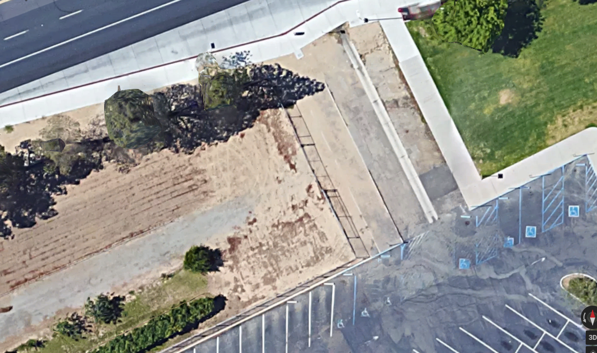

C. Technology and Equipment:
- Understanding that some programs teach in multiple classrooms, how has new, repurposed or existing technology or equipment affected your program in the past year as it relates to student success?
- How will your new or repurposed classroom, office technology and/or equipment request contribute to student success?
- Discuss the effectiveness of technology used in your area to meet college strategic goals.

D. Budget: Explain how your budget justifications will contribute to increased student success for your program.

VII. Faculty and Staff Engagement:
- Discuss how program members have engaged in institutional efforts such as college committees, presentations, and departmental activities.
The previous construction instructor, who retired in May 2016, was not involved with the campus community. The new instructor came to BC with prior community college teaching experience and will be engage the campus community through presentations.

- Instruction Only: Discuss how adjunct faculty is included in departmental training, discussions and decision-making.
The new instructor values the contribution of adjunct instructors to the construction program and is coordinating the curriculum with the sole adjunct. The revised curriculum will be more modular than the current 7-unit/15 hour classes and will provide the opportunity to additional adjuncts to be hired.

VIII. Conclusions and Findings:
Present any conclusions and findings about the program. This is an opportunity to provide a brief abstract/synopsis of your program’s current circumstances and needs.

